

Google**ECOM**

**FYP Proposal Defense**

**K H I Z A R | I B T I S A A M | A T I F**

# Short Title

GoogleECOM

# Complete Title

Google Energy Control & Packet Tracing Monitor

# Type

Research & Development

# Group Information

|  |  |  |  |
| --- | --- | --- | --- |
| Name | Roll Number | Email | CGPA |
| Khizar Naseer Butt | I15-0024 | [I150024@nu.edu.pk](mailto:I150024@nu.edu.pk) | 3.11 |
| Ibtisaam Butt | I15-0027 | [i150027@nu.edu.pk](mailto:i150027@nu.edu.pk) | 3.54 |
| Malik Atif Aziz | I15-0057 | [I150057@nu.edu.pk](mailto:I150057@nu.edu.pk) | 2.87 |

# Supervisor

Dr. Mirza Omer Beg – Assistant Professor, CS Department, National University of Computer & Emerging Sciences, Islamabad

Signature: _________________

# Project Overview

# Motivation

Around 3.7 billion people in world have access to technology and it is their utmost priority that during their use of internet, their personal information must not be prone to any form of leakage or exploitation. These devices have access to personal, potentially sensitive data, and there are growing numbers of applications that transmit this personally identifiable information (PII) over the network.

Our intentions are to empower the users to take control of their sensitive data by interacting with them through an Application that will demonstrate the to-and-fro transfer of information from source to destination and vice-versa and it shall permit the operator to stop that leakage or transfer.

Another major motivation is to assist community by prolonging the lifetime of their devices which will be possible by calculating the amount of Joules being consumed for data transfer and prompting the user so that he or she may save the battery drainage which will eventually prolong the lifetime of device’s battery.

# Scope/High Level Features

The Scope of this project consists of four major components:

* The first component involves collection and generation of dataset of labeled network packets which can later be used to predict the packets as Personal Identified Information.
* The second component consists of training a regression model for energy consumption and usage of network data packets which we would refer as Personal Identified Information.
* The third component will comprise of development of a web based application programmable interface to visualize our findings. Breach of personal identified information along with energy consumption will be visible to the device user.
* The last component focuses on the writing of a research paper in which we will summarize our findings, along with a complete carbon footprint of Google’s android operating system. The research paper will also enlighten our findings on privacy and data breach along with calculating energy consumption for this particular type of data. We will also suggest solutions to the problems of data breach and energy wastage present at hand.

# Goals/Objective

The International Telecommunication Union (ITU), a United Nations body, predicts that **4 billion people** will be online by 2020. Cisco, the networking company that supplies much of the world's internet infrastructure, says that the total amount of traffic will reach around **1,060 exabytes**, or just over one zettabyte. This huge amount of data maybe at risk of leakage and our ultimate goal is to empower people as we end this project in 2019, and optimizing the amounts of energy consumed by all these packets.

# Expected Outcomes

* A complete tested carbon map of Android Operating System.
* A tested and verified graphical user interface application displaying the transfer of data from applications to their respective servers and Google servers.
* Our application will also display the amount of energy being used for the above protocols.
* A research paper consisting of our enlisted findings along with an estimate energy usage for storing and analyzing of the transferred data.

# Tools/Technologies/Expertise

|  |  |  |  |
| --- | --- | --- | --- |
| **Tools** | **Khizar Naseer** | **Ibtisaam Butt** | **Atif Aziz** |
| Python 3 | 10 | 10 | 7 |
| C# | 10 | 10 | 9 |
| JavaScript | 8 | 6 | 7 |
| Angular 4 | 10 | 6 | 9 |
| HTML 5 | 8 | 8 | 8 |
| Bootstrap | 8 | 7 | 7 |
| Android Studio | 8 | 7 | 7 |
| Wireshark | 8 | 8 | 6 |
| Trepn Profiler | 4 | 4 | 4 |

**Timeline**

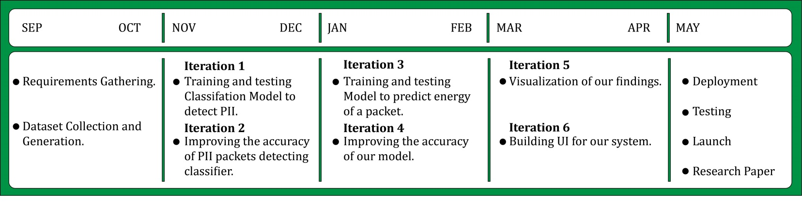

# References

# *AntShield: On-Device Detection of Personal Information Exposure*

[Anastasia Shuba](https://arxiv.org/search/cs?searchtype=author&query=Shuba%2C+A), [Evita Bakopoulou](https://arxiv.org/search/cs?searchtype=author&query=Bakopoulou%2C+E), [Milad Asgari Mehrabadi](https://arxiv.org/search/cs?searchtype=author&query=Mehrabadi%2C+M+A), [Hieu Le](https://arxiv.org/search/cs?searchtype=author&query=Le%2C+H), [David Choffnes](https://arxiv.org/search/cs?searchtype=author&query=Choffnes%2C+D), [Athina Markopoulou](https://arxiv.org/search/cs?searchtype=author&query=Markopoulou%2C+A)

* ***AntMonitor: System and Applications***

Shuba, Anastasia & Le, Anh & Alimpertis, Emmanouil & Gjoka, Minas & Markopoulou, Athina. (2016).